
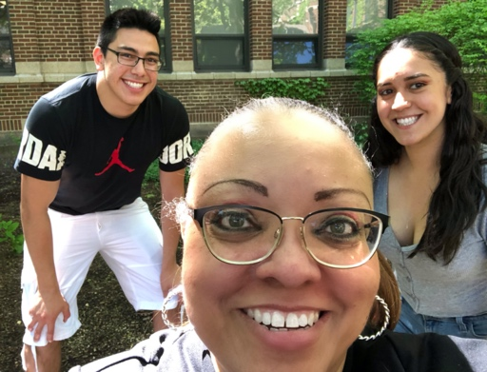

Mrs. Gordon
Mrs. Gordon
Mr. Stone
Jenny
Ulysses
Mr. Feeley
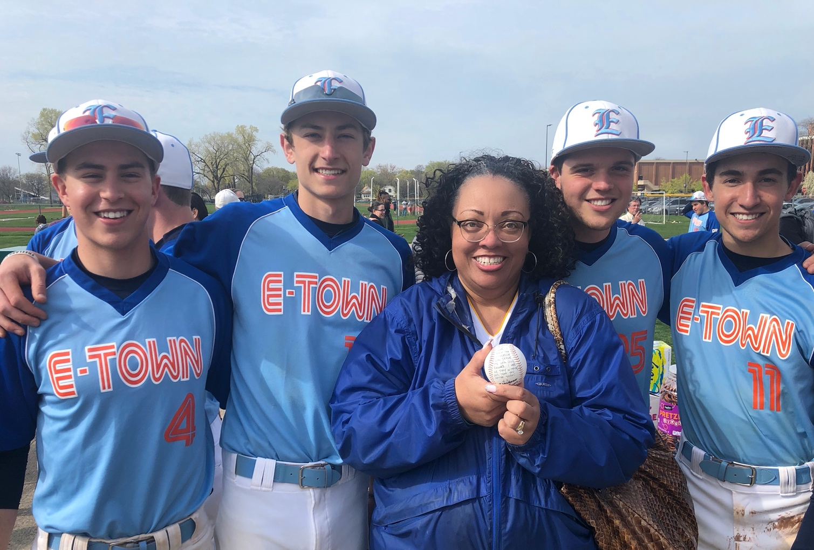


WELCOME BACK!!!
Mr. Buff
ETHS Varsity Baseball Players 2017-2018
Mr. Gordon

Dear ETHS Parents/Guardians & Students:

Hello, my name is Darlene Gordon and I will have your son or daughter as a student this coming fall as Evanston Township High School begins its 2020 academic year remotely.

Some of you may know me because you have another child who might have been a student of mine in the past, or, perhaps your son or daughter is a returning scholar, having taken a class in a previous semester. Either way, if I have not had the pleasure of meeting you or your child, I greatly look forward to getting to know you and to teaching your student, albeit remotely, when the new year starts up in a few weeks.

A little about me: I am starting my 12th year as an educator, all of those spent at ETHS.
I worked in the corporate sector for a while prior to my teaching career, mostly in consulting (Accenture, McKinsey & Co) and law (Mayer Brown and Sidley & Austin LLP). My educational credentials include a B.A. in Marketing, an M.A. in 20th Century Urban History and I am currently completing a doctorate in Educational Leadership, all from DePaul University. I also hold a 2nd master’s degree in Ed Leadership with a Principal’s licensure from National Louis University. I have sponsored several clubs here at ETHS—Kellogg Connections, the ETHS Film Club, Intersectional Women United, and I will be starting two new extracurricular clubs in the fall—Women in Business/STEM and a student-led club focusing on those interested in politics and democracy, which is yet to be named. I teach business classes (personal finance, marketing and entrepreneurship) as well as government and public safety. I am married to a former teacher and have an 8-year old chocolate lab rescue named Buff (see their pictures above). I enjoy my career as an educator immensely and I think it’s the best job in the world, bar none.

So, now to the point of my message. We probably all feel some measure of anxiety about the start of a new school year that will be unlike any other we’ve experienced before. I am writing to try and calm your worries and fears about the sort of experience your child will be having in this new, remote format. Even though we are starting the school year remotely, and even though some of the data and lessons we’ve been able to look at from last academic year indicate that e-learning is not the best environment for every student to be able to learn, grow and achieve, I am confident that students and teachers can make the experience one that is beneficial. I am looking forward to having your child in my virtual classroom. Many of my colleagues (and I) have spent the past several weeks training on how to make the online learning experience optimal for our students at ETHS. There are many advantages to the use of technology in learning that I plan on taking advantage of during my remote classes. As well, it is my desire to get to know each student and understand what his or her concerns and hopes for the school year are. I believe that every young person wants to learn and be successful and I want both parents and students alike to know that this is my priority as well. Though this is a new experience for all of us, I am confident that we can have a worthwhile and successful time together exploring the topics of government, public safety, and entrepreneurship.
We can do it!

So, having said that, below are descriptions of the classes that I am teaching this semester and what your son or daughter can expect in terms of a course overview when we start class on
Monday, August 17, 2020:

Intro to Public Safety
This course introduces students to two areas of public safety: law enforcement and fire science. Fire content instructs the student on fire department organization and operations and general aspects of fire science. Law enforcement content covers police department organization and operations and a variety of criminal justice careers. This course provides all students with an articulated road map to honors credit. Honors credit is recognized at the end of each semester based on the successful completion of the pathway.

AP U.S. Government & Politics
Students gain a critical perspective on United States politics and government. The course content is used to interpret United States politics and examine the various institutions, groups, beliefs, and ideas that make up American politics. Topics covered will include the constitutional underpinnings of U.S. government; political beliefs and behaviors; political parties, interest groups, and mass media; institutions of national government; public policy; and civil rights and civil liberties. In addition, a primary purpose of the course is to explore careers and career pathways in government and politics. The course is taught with college-level texts. There is a summer assignment that is due on the first day of school, August 17. Course assessments include weekly quizzes, unit tests, cooperative group projects and Document Based Question (DBQ) writing assignments with the goal of preparing students for the AP exam, which is a key focus of the course. Every student is expected to take the AP exam in May 2021.
Algebra in Entrepreneurship
Algebra in Entrepreneurship is a interdisciplinary course that integrates Algebra with topics in business, focused on entrepreneurship. By infusing numeracy instruction with project-based learning and a real-world context, students will gain a deeper understanding of both Algebra and Entrepreneurship. The Algebra content mirrors that of other 1 Algebra courses taught in the Mathematics Department and prepares students for the subsequent Geometry course. Students will work on a variety of business problems/projects increasing in complexity including developing estimates and forecasts, market research and assessing data; assigning cost & pricing of products/services; and formulation of a business concept including projected financial statements. Additional emphasis will be given to teamwork, problem-solving, public speaking, and the application of technology including spreadsheets, as a vital tool for applying math in business. Early calculus topics will be explored through marginal analysis, profit, revenue, and cost functions. Students earn credit for Algebra and for Entrepreneurship in this double-period course. The entrepreneurial portion of the course provides all students with an articulated road map to honors credit. Honors credit is recognized at the end of each semester based on the successful completion of the pathway.

To prepare your student for online learning, please make note of the following tips:
- Make sure your student has a district-issued Chromebook that is in good working condition,
a reliable high-speed internet connection, all of their textbooks and other materials being distributed by teachers of classes on their schedule, and a quiet place to work and study. ETHS will be communicating with you on pick-up dates and times in order to get technology and materials for your student—freshmen, for example, are scheduled to start picking up their materials beginning August 7.
- Get your student in the habit of rising early, just as if he or she would be coming into the ETHS building to attend class. Students should get rest the night before, rise, take care of personal hygiene and get dressed for school. A hot breakfast is always a great way to start the day so that your child can be ready to engage the e-learning school day at 9:00 am sharp. The e-learning school day will be a full day of instruction on a scattered schedule. It will be something that most ETHS students have not experienced before and it will take some getting used to. A copy of the new BLUE and ORANGE bell schedule which will structure our e-learning day is shown below. Click on the image itself to read more about the new ETHS Re-Opening Framework.
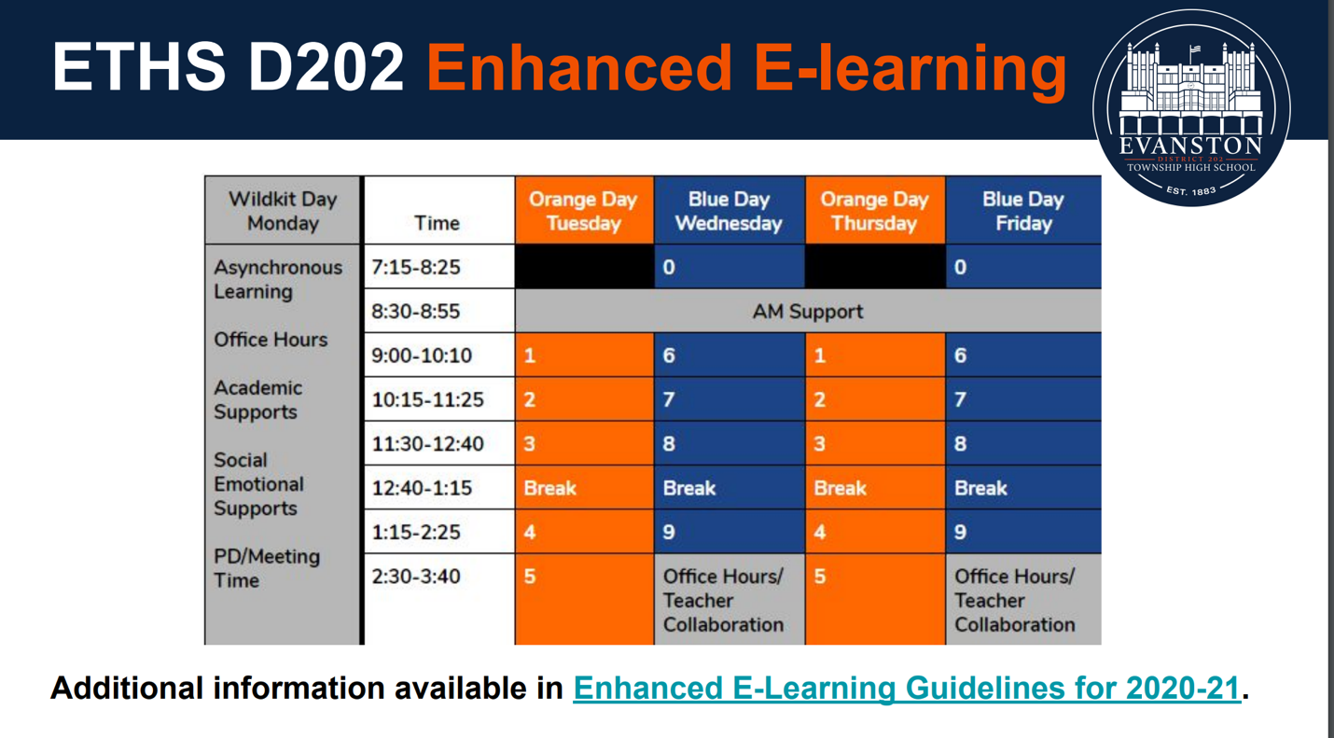
- Get yourself and your student up and running on HAC – The Home Access Center. HAC is how you can see your child’s assignments, grades, check their attendance, pay any fees and a number of other pieces of information that you will need to successfully navigate the ETHS world. Go to https://www.eths.k12.il.us/onlinetools and click on the question mark next to the Home Access Center icon for more information.
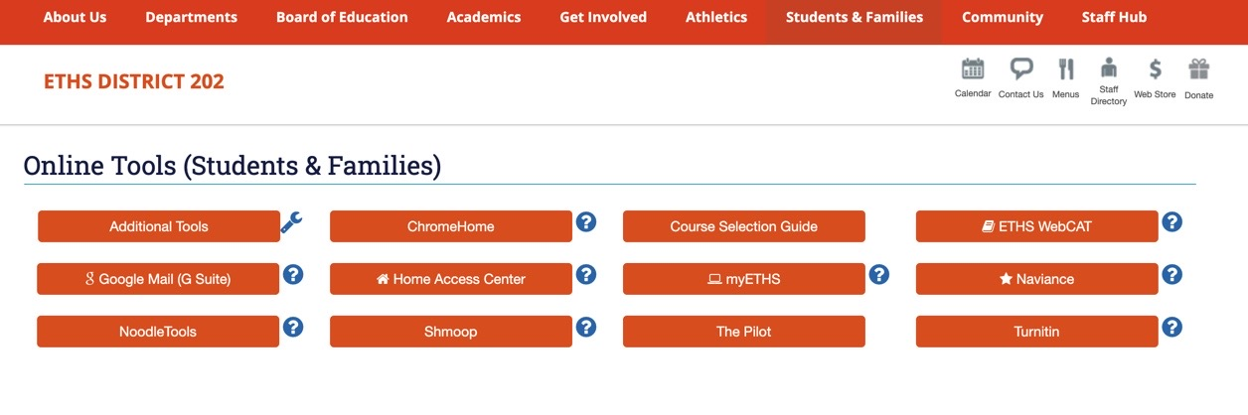

- School Supplies: Please make sure your student has the normal school supply kit for class,
which would include:
  - A multi-subject spiral notebook to take notes in
(or several individual spiral notebooks, one for each class on their schedule)
  - Pens & Pencils
  - 1-2 Erasers
  - An external flash drive to save data on to
(8GB of storage should be sufficient for most students)
  - Color highlighters
  - An assignment notebook specifically for writing down assignments and upcoming project due dates (some students utilize their cellular phone for this but whatever is used, the student should have a place to write these down and use a regular practice of recording assignments in order to keep track of what is coming up in terms of homework, exams and projects). Learning to turn quality work in on time is essential as young people leave high school and transition into young adulthood.
Lastly, I would ask you to encourage your son or daughter to embrace, as much as they can, the idea of online or e-learning. We do not know how long this system will be in place or exactly when a part- or full-time schedule of in-person instruction will return to availability. Parents and students should know that ETHS teachers would much rather be in class, face-to-face, engaging our students and working together, especially at a critical time such as this, the start of a new school year. However, the COVID-19 pandemic has forced everyone into a new normal. We all want to be safe and able to learn in an environment that is a healthy one. I really hope to be able to return to my classroom as soon as medical professionals and science tells us that we can do so safely.

In the meantime, I intend to make our online experience a rigorous and engaging one for all of my students. This means an immersion into content and materials in ways that match your son’s or daughter’s learning profile and interests. I will adjust the pace with which I teach to match the needs of my student’s readiness levels, understanding that online learning is a challenge for many students in the Evanston community. There will be reading, critical thinking, group work, projects and online discussions to match the content of the course descriptions shown above. There will also be time for students to engage with me, one-on-one and real-time, during my office hours, and AM Support and through safe text messaging apps like Remind. We will also be utilizing Google Meet and Google Classroom in my classes and I will offer a demo for students on how these two resources will work once we get started.
Students and parents should feel free to communicate with me about courses, assignments or any other questions that may arise. To this end, I am sending you my contact information:

Mrs. Darlene Gordon
New! Cell: (847) 636-1746
Remind: will be set up the week before school starts and I will send that information to
parents & students via e-mail.
Email: gordond@eths202.org

I will be conducting an online Zoom session for Q&A about the upcoming school year on
Tuesday, August 12, 2020 at 12 pm CST. This session will be open primarily to students. Parents, if you have a question or concern, I encourage you to email me so that we can set a time to speak directly. I am available for consultation starting August 3rd.

Topic: Q&A on the Upcoming ETHS School Year
Time: Aug 12, 2020 12:00 PM Central Time (US and Canada)
Join Zoom Meeting
https://us02web.zoom.us/j/7515300432?pwd=UTRTbFNBeVV0T0ZDY1B0L1hEQnJwdz09

Meeting ID: 751 530 0432
Passcode: 312040
______________________________________________________________________________

AP U.S. Government & Politics students! There will be an online Zoom workshop held to discuss expectations for the summer assignment and the upcoming year in AP U.S. Government & Politics on August 5, 2020 @ 11 am! AP Gov students, please prepare for this workshop, read the assignment rubric (contained in the link below) and have questions about the required essay written down ahead of time.
Topic: AP U.S. Government & Politics Summer Workshop
Time: Aug 5, 2020 11:00 AM Central Time (US and Canada)

Join Zoom Meeting
https://us02web.zoom.us/j/7515300432?pwd=UTRTbFNBeVV0T0ZDY1B0L1hEQnJwdz09

Meeting ID: 751 530 0432
Passcode: 312040

AP U.S. Government Summer Assignment Rubric

______________________________________________________________________________
I hope this communication has been helpful to you. I am hopeful that by reaching out early, I can reassure both students and parents that even though we will be starting with a new normal on
August 17 (the first day of school), I firmly believe, that together we can have a successful, engaging beginning to our school year!

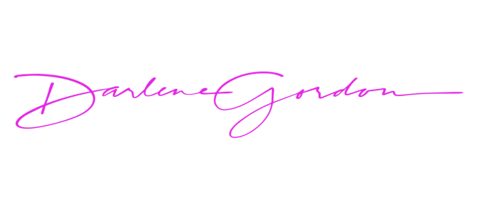
I look forward to seeing and talking to all of you very soon!
My very best,

